# **Subject line:**

[redesigned logo for April fools]

# Intro

Bing bong boogie woogie, welcome back to SOCHI! Today is April Fools, as you may have guessed, so in celebration, we made this very awesome video [here](https://www.youtube.com/watch?v=xvFZjo5PgG0)! Steven is ABSOLUTELY feeling unhinged today.

*-Steven Liu, Reuben Crasto*

# Upcoming Events

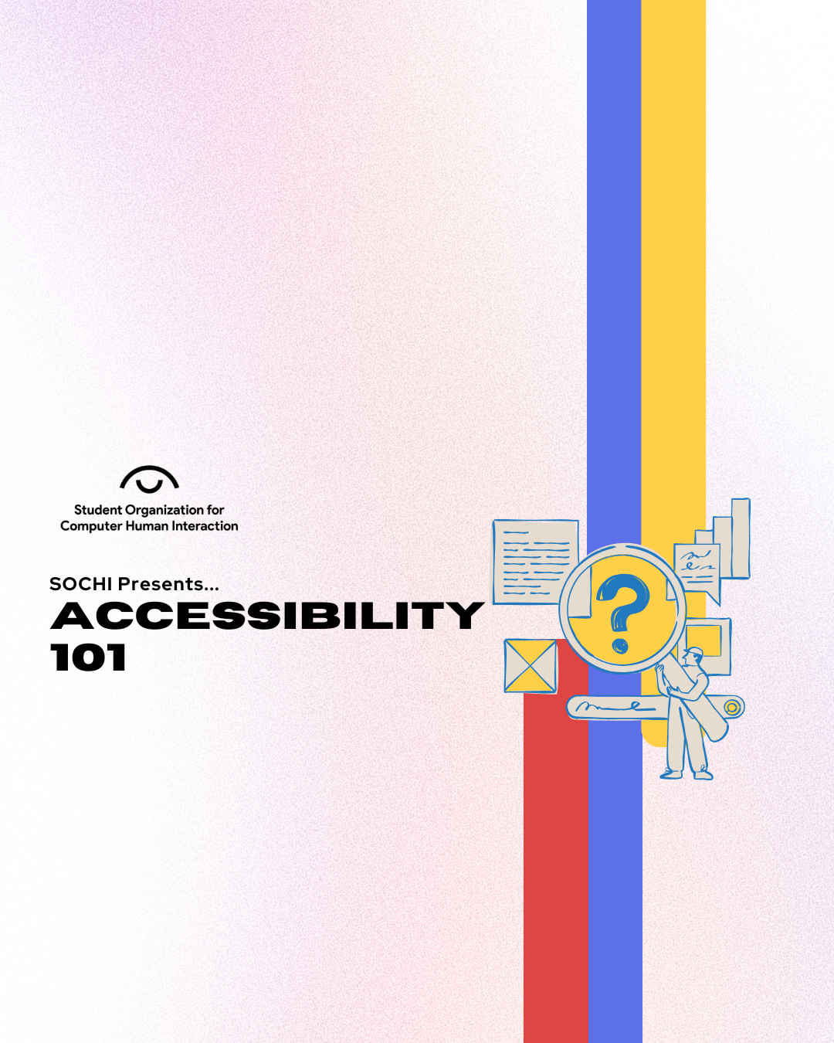

Expand your UX toolkit with a focused session on designing for accessibility. Join us on **Friday April 4th, 2pm at NQ2175** as we dive into essential practices like color contrast, structure, target spacing, and accessible text and work on creating accessibility-compliant UI components!

# Body Sections

Recently, I had the absolute privilege of using Truth Social, Donald J. Trump's premier social media platform for an assignment in SI 110. And boy, was it a journey.

Truth Social pilots mostly like Twitter. Users can ‘Truth’ whatever’s on their minds, and ‘ReTruth’ others, just like tweeting and retweeting on Twitter. But it also incorporates Groups, similar to Facebook Groups. Most groups don't have much engagement; after all, people are NOT coming to Truth Social for funny cat pictures.

Speaking of engagement, Truth Social has [stated](https://www.axios.com/2024/03/27/truth-social-stock-facebook-twitter-ipo) that it will not disclose its number of active users, but based on estimates it has 1.5 million monthly users, well below even other niche platforms like [Bluesky](https://backlinko.com/bluesky-statistics). Given the amount of status tracker bots and hashtag spammers, I don't believe there's actually that many actual users on it besides Trump himself, who posts up to *twenty times a day.* But there are real people on Truth Social, which is what makes the experience so disheartening.

We should acknowledge that Truth Social is the mother of all echo chambers, a breeding ground for every conservative rhetoric. I will spare you from the worst of the storms since much of Truth Social's content has no business seeing the light of day. I also wonder if some users are actually sincere in their posts.

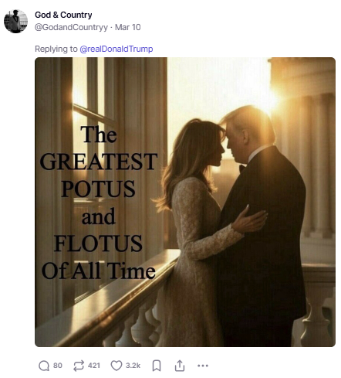

One interesting phenomenon I noticed is the response to news on Truth Social. For example, after the tragic helicopter crash in January, Trump [pointed](https://www.bbc.com/news/articles/cpvmdm1m7m9o) the finger at DEI initiatives in the Federal Aviation Administration. On that day I was perusing Truth Social, and #DEI was the top trending hashtag. The posts containing the hashtag weren't much better.

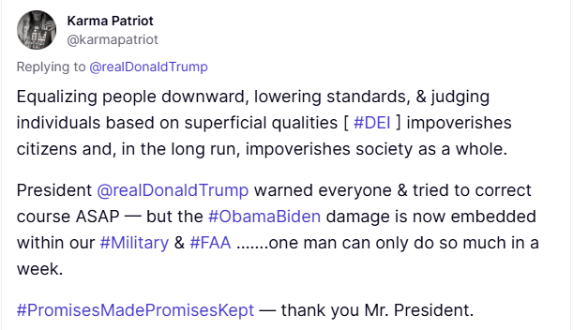

I realized that while we always discredit right-leaning opinions especially on such a liberal campus as Umich, I'm filled with empathy towards people who hold these extremist views. It is true that choosing to believe this way is a deliberate choice that they made, but if I’d grown up in a different place or followed a different algorithm, who knows?

All in all, my Truth Social tour was chaotic, baffling, and kind of hilarious, but also a reminder of how all beliefs are repeated and echoed back at us. I’m never opening Truth Social again, but at least I’ll walk away with a perspective from the other side. And, hey, maybe that’s progress.

# Game

Ooookk! Time for a game!